Editable Message Templates  
for the EASE Informational Campaigns

This is a version of the messages used in the two EASE informational campaigns that administrators can download, copy and customize, for use with the Pell Grant calculator. The suggested timing, mode of communication, and sender are noted before each message; yellow-highlighted fields are student-specific personalized fields, and gray fields are college-specific. Check out Part II of the [EASE Handbook for Community Colleges](https://www.mdrc.org/publication/ease-handbook-community-colleges) for additional tips and annotations that can help you implement the best program for your school, and try to maintain the behavioral science elements developed by EASE study researchers and outlined in the handbook.

Strategy 1

Message Templates for Informational Campaign  
Without Tuition Assistance

# Message 1

**Message timing:** Three days before summer registration opens.

**Mode:** Email

**Recommended sender:** Registrar, Enrollment, or Student Success

**Tips for sending Message 1:** Use the most direct link possible to your college’s summer course schedule.

**Subject:** You have funding for summer courses! Sign up on [**College’s summer registration open date**].

Hi [Student First Name],

I have good news! I took some time to review your records and identified you as a student who will benefit from the year-round Pell Grant. **This means you have additional Pell funding* for summer [year] courses that you do not need to pay back!**

Whether your goal after getting a degree from [College Name] is to get a great job, support your family, transfer, or learn new skills, **summer courses will help you get there faster**. Research shows that students who take summer classes have higher GPAs and are more likely to graduate. Take advantage of your Pell funding by enrolling in a course you didn’t have a chance to take in the spring, or getting a head start on fall courses.

[College Name] offers a variety of summer course options, including online and evening classes, to fit your schedule. Take 10 minutes today to think about what courses you could take. Click [here] to view the summer course schedule.

**Registration opens on** [**College’s summer registration open date**]. See you this summer!

Sincerely,

[Sender First and Last Name]

Registrar

P.S. Would you like your advisor to recommend summer courses that will help you complete your degree? Contact your advisor, [name] at [email] or [phone number]. I’m confident we can find a summer schedule that works for you!

*Funding contingent on remaining a Pell Grant recipient in summer [year].

# Message 2

**Message timing:** The day summer registration opens—after online registration has officially opened.

**Mode:** Email

**Recommended sender:** Advising

**Tips for sending Message 2:** Customize “simple steps to enroll” by laying out how students can select and register for summer courses.

**Subject:** Summer registration is open. How many courses will you take?

Hi [Student First Name],

**Summer registration is now open!**

Taking summer classes is the best way to stay on track towards getting your degree. In fact, many of your classmates at [College Name] attend summer classes to graduate faster. I want to make sure you don’t miss out on this opportunity.

Secure your spot in the classes you need by taking a few minutes to register for summer courses right now. Follow these simple steps to enroll:

1. Look at the summer course schedule [here] and write down three courses that you need for your degree program that you haven’t taken yet.
2. Choose courses that work with your summer schedule
3. Register for your summer courses at [student registration portal]

Keep in mind that you are eligible for the **year-round Pell Grant.\*** This means you have funding available for summer courses!

If you need advice, take 15 minutes this week while on campus to check in with me. You can contact me at [advisor e-mail] or [advisor phone] to schedule a brief advising session.

Sincerely,

[Sender First and Last Name]

Academic Advisor

*Funding is contingent on remaining a Pell Grant recipient in Summer [year].

# Message 3

**Message timing:** Mail the week of summer registration opening

**Mode:** Mailed postcard

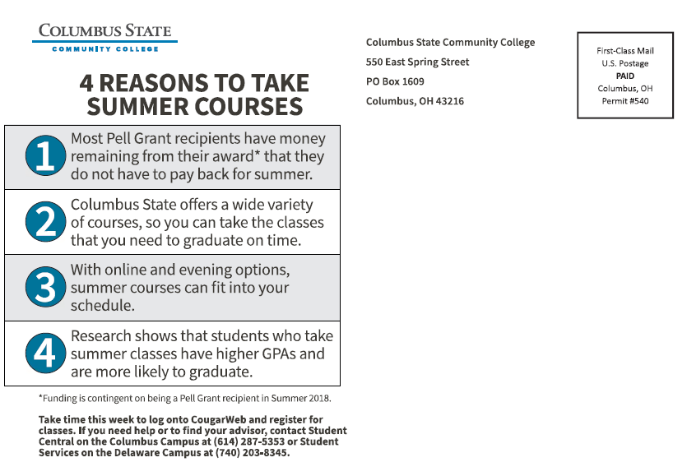**Tips for sending Message 3:** This postcard is just an example. You may use similar language and images to design your own and customize to your needs. Be sure to maintain use of the behavioralprinciples.

**Front of postcard**

**Back of postcard**

# Message 4

**Message timing:** Message 4 should be sent after financial aid “freeze” date

**Mode:** Email

**Recommended sender:** Financial Aid office

**Tips for sending Message 4:**

* The MDRC Pell Grant Spreadsheet [hyperlink] can help you create the estimates for the chart.
* Qualitative research suggested that students may be more likely to open communications from Financial Aid.

**Subject:** You have funding for summer courses!

Hi [Student Name],

I am pleased to let you know that **you have up to $[Pell if enrolled full time]* from the year-round Pell Grant to use for summer courses**.

I strongly recommend you take at least one summer class, because this is financial aid **you do** **not have to pay back**. Don’t miss out on the opportunity to take advantage of your funding and get ahead in your education.

Your grant award will depend on how many summer courses you take. Use this chart* to determine how many courses you should plan to take this summer:

|  |  |
| --- | --- |
| **If you take…** | **You will receive…** |
| 1 to 5 credits | [$Pell if enrolled <1/2 time] |
| 6 to 8 credits | [$Pell if enrolled ½ time] |
| 9 to 11 credits | [$Pell if enrolled ¾ time] |
| 12 or more credits | [$Pell if enrolled Full Time] |

If you have questions about your financial aid, email me, call [financial aid phone number], or visit the Financial Aid office, located at [location].

Best,

[Sender First and Last Name]

Financial Aid

*Important notes:

Funding is contingent on remaining a Pell Grant recipient in summer [year].

Values in the chart are estimates based on your Expected Family Contribution (EFC) and enrollment history.

# Message 5

**Message timing:** Message 5 should be sent one week after Message 4.

**Mode:** Mailed letter

**Recommended sender:** Financial Aid

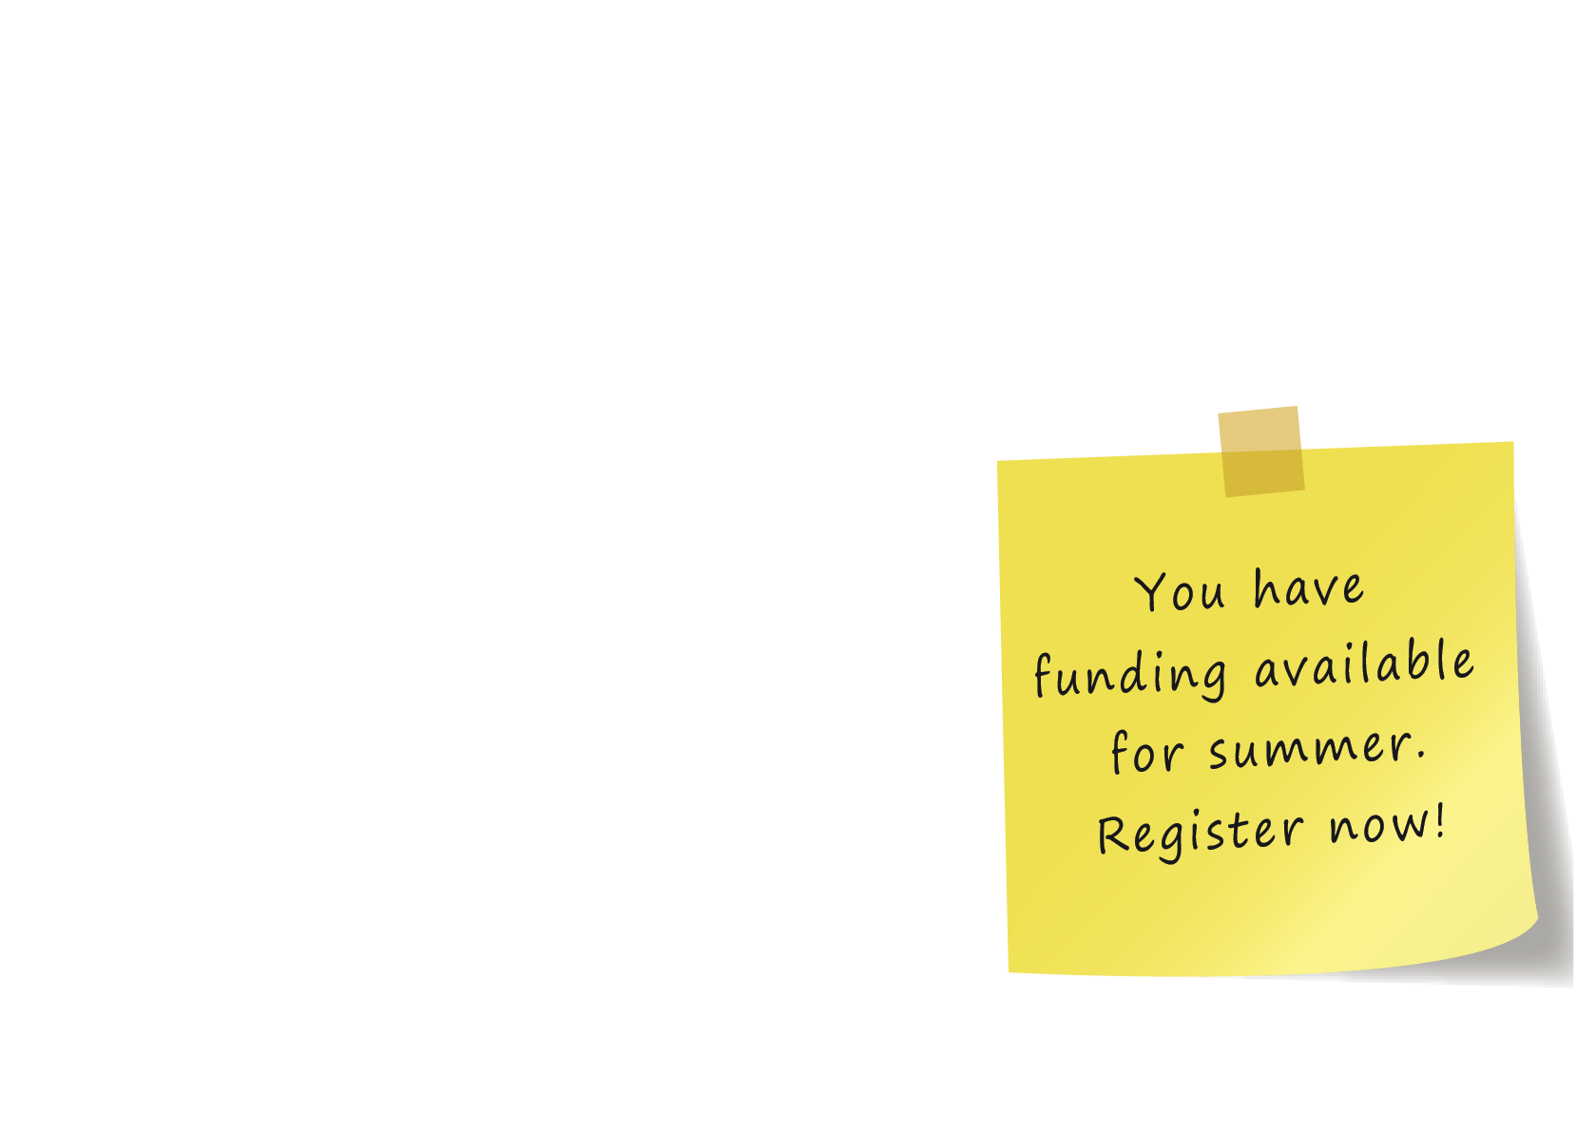**Tips for sending Message 5:** While many colleges no longer send postal mail to students, qualitative research from the EASE project suggests that students are more likely to recall the mailed letter. To engage as many students as possible, send both message 4 and message 5.

[Place on College’s Letterhead]

[Date]

Dear [Student First Name] [Student Last Name],

The [College] Financial Aid Office has reviewed your records, and I am pleased to let you know that, because of the new year-round Pell Grant policy, **you have Pell funding* available to use for summer courses**. I strongly recommend you take at least one summer class, because this is financial aid **you** **do** **not have to pay back**.

Your grant award will depend on how many summer courses you take. Use this chart* to determine how many classes you should plan to take this summer:

|  |  |
| --- | --- |
| **If you enroll in…** | **You will receive…** |
| 1 to 5 credits | [$550] |
| 6 to 8 credits | [$1,100] |
| 9 to 11 credits | [$1,650] |
| 12 or more credits | [$2,200] |

Your Pell Grant is valuable. Use it to take a step closer to graduation.

If you have questions about this award or your financial aid package, contact the Financial Aid Office at  
[xxx-xxx-xxxx], [[financial aid](mailto:financialaid@state.edu) email], or come visit us at [location].

Sincerely,

[Name]

Financial Aid Office

[College]

*Important Notes:

Funding is contingent on remaining a Pell Grant recipient in summer 2018.

Values in the chart are estimates based on your Expected Family Contribution (EFC) and enrollment history.

# Messages 6a and 6b

**Message timing:** Message 6a or 6b should be sent about one week after Message 5.

**Mode:** Email

**Recommended sender:** Advising

**Tips for sending Message 6:**

* Some colleges in the EASE project ran degree audits to create personalized course recommendations for students. Other colleges found this too difficult and provided alternatives. For example, one college informed students of common courses or requirements that others in the student’s major usually take during the summer.
* Message 6a is for students who have not registered for summer courses and Message 6b is for students who have registered.

# Message 6a

**Subject:** Your summer course recommendations

Hi [Student First Name],

I took some time to run a degree audit for you. According to [College’s] system, you are a [major] major. As of [date of audit], I see that you are not registered for summer courses. Here are a few courses you need for your degree that are offered during the summer:

* **[Course number 1: Name of course 1]**
* **[Course number 2, Name of course 2]**
* **[Course Number 3, Name of course 3]**

Register on [registration portal name with hyperlink], so you don’t lose your spot!

If you have questions or need help registering, contact Advising at [email] or [xxx-xxx-xxxx].

Sincerely,

[Name]

Academic Advisor

P.S. The new year-round Pell Grant means you have funding for summer courses, as long as you remain a Pell recipient in summer [year]—don’t miss out!

# Message 6b

**Subject:** Your summer course recommendations

Hi [Student First Name],

I took some time to run a degree audit for you. According to [College’s] system, you are a [major] major. As of [date of audit], I see that you are registered for the following summer course: [Course 1]. This is great news!

If you would like to take another course, here are additional courses you need for your degree that are offered this summer:

* **[HDU 008, Name of course]**
* **[ENG 101, Name of course]**

Register [here (hyperlink)] now, so you don’t lose your spot!

If you have questions or need help registering, contact Advising at [email] or [xxx-xxx-xxxx].

Sincerely,

[Name]

Academic Advisor

P.S. The new year-round Pell Grant means you have funding for summer courses, as long as you remain a Pell recipient in summer [year]—don’t miss out!

# Message 7

**Message timing:** Message 7 should be sent about one week after Message 6.

**Mode:** Mailed letter

**Recommended sender:** Student Success

**Tips for sending Message 7:** The testimonials presented here were gathered from students at community colleges in Ohio during the EASE project. You can use these or collect your own testimonials.

[College letterhead]

[Date]

Dear [Student First Name] [Student Last Name],

As you may have heard around campus, many of your classmates are signing up for summer courses to get the most out of their time at [College]. The exciting new year-round Pell Grant* means **you have funds for summer that you do not have to pay back**.

I wanted to share a couple of stories from students like you who got the most out of their summer by taking classes:

*“I wasn’t sure in the beginning if I was going to take summer courses, but I am very happy that I did. It helped me not lose focus and just kept me on track… The workload part of it is huge for me because I won’t have to stress out with taking two additional classes on top of my nursing program. And without doing summer, I wouldn’t have been able to achieve that.”*

*-Heather I., Nursing student*

*“I think of it as a win-win situation. I was able to finish my modern language requirement as a result of taking a summer course. I had a couple friends in the class, and we would typically study after classes together…it was a good experience overall.”*

*-Jacob B., Associate of Arts*

Make sure you don’t miss out on this opportunity! If you haven’t already done so, log in to [College registration portal] to register for summer courses by [date].

Sincerely,

[Name]

[Student Success]

[College]

*Funding is contingent on remaining a Pell Grant recipient in summer [year].

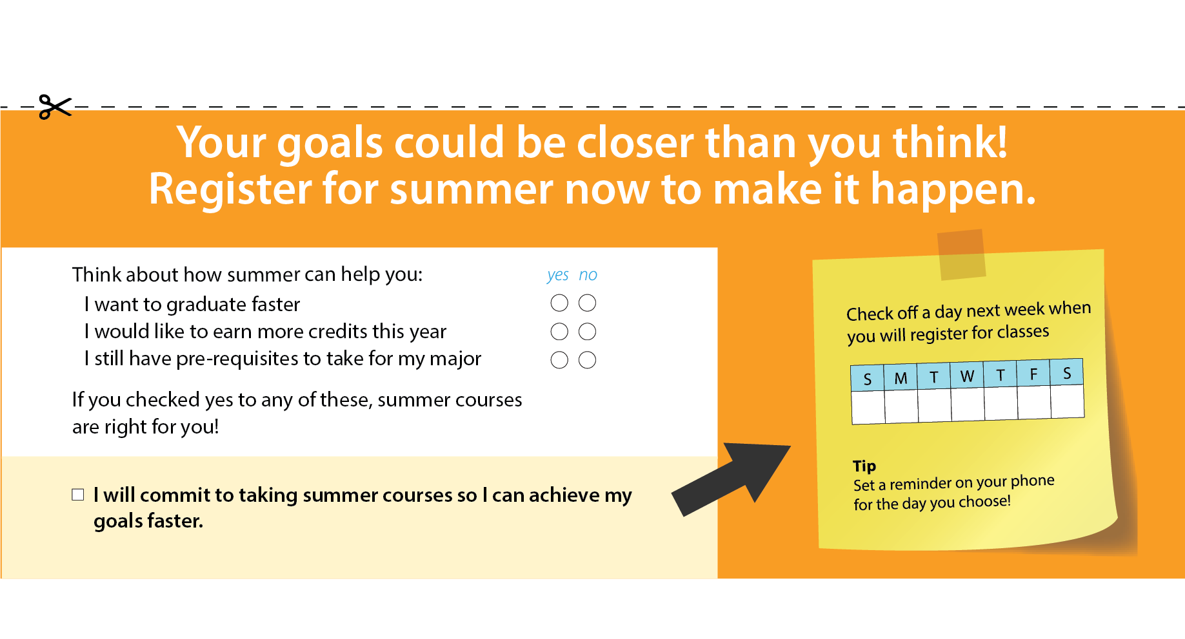

# Messages 8a and 8b

**Message timing:** Message 8a or 8b should be sent two weeks before summer registration closes.

**Mode:** Email

**Recommended sender:** Registrar

**Tips for sending Message 8:** Message 8a is for students who have not registered for summer courses and Message 8b is for students who have registered.

# Message 8a

**Subject:** There’s still time to register for summer courses!

Hi [Student Name],

**Summer registration closes on [date]—register today!**

Keep in mind a few reasons you should take summer courses:

1. Pell Grant recipients have money remaining from their award that they do not have to pay back.
2. [College Name] offers a variety of courses, so you can take the classes that you need to graduate on time.
3. With online and evening options, summer courses can fit into your schedule.
4. Research shows that students who take summer courses have higher GPAs and are more likely to graduate.

Click [here] and log in to [College portal] to register now so you can reserve a spot in the courses you need.

Sincerely,

[Name]

Registrar

*Funding is contingent on remaining a Pell Grant recipient in summer [year].

# Message 8b

**Subject:** Four reasons summer courses are a good idea

Hi [Student First Name],

I reviewed your registration status, and I am excited to see that you have signed up for summer courses!

Keep in mind a few reasons why it’s a good idea to take courses in summer:

1. Pell Grant recipients have money remaining from their award that they do not have to pay back.
2. [College Name] offers a variety of courses, so you can take the classes that you need to graduate on time.
3. With online and evening options, summer courses can fit into your schedule.
4. Research shows that students who take summer courses have higher GPAs and are more likely to graduate.

Sincerely,

[Name]

Registrar

*Funding is contingent on remaining a Pell Grant recipient in summer [year].

# Messages 9a and 9b

**Message timing:** Message 9 should be sent the Thursday before summer classes begin.

**Mode:** Email

**Recommended sender:** Registrar

**Tips for sending Message 9:**

* The testimonials presented in 9a and 9b were gathered from a student at a community college in Ohio during the EASE project. You can use this or collect your own testimonial.
* Message 9a is for students who have not registered for summer courses and Message 9b is for students who have registered.

# Message 9a

**Subject:** Summer courses start on [day] – last chance to register!

Hi [Student First Name],

Summer courses start on Monday, and there are still a few spots left. Don’t miss out on this opportunity! Click [here (hyperlink)] to log in to [College portal]. Register by [date] to reserve a spot in the courses you need for your degree.

Check out Heather’s story of getting the most out of her summer:

“*I wasn’t sure in the beginning if I was going to take summer courses, but I am very happy that I did. It helped me not lose focus and just kept me on track… The workload part of it is huge for me because I won’t have to stress out with taking two additional classes on top of my nursing program. And without doing summer, I wouldn’t have been able to achieve that.”*

*-Heather I., Nursing student*

Sincerely,

[Name]

Registrar

# Message 9b

**Subject:** Summer courses start on [day] – what are your goals?

Hi [Student Name],

Summer courses begin on Monday!

Take a second to remember why you signed up for your summer course. Write down 3 goals you are hoping to achieve by taking a summer course and put these goals in a visible place. This will help you stay motivated throughout the summer.

Check out Heather’s story of getting the most out of her summer:

“*I wasn’t sure in the beginning if I was going to take summer courses, but I am very happy that I did. It helped me not lose focus and just kept me on track… The workload part of it is huge for me because I won’t have to stress out with taking two additional classes on top of my nursing program. And without doing summer, I wouldn’t have been able to achieve that.”*

*-Heather I., Nursing student*

Stay focused and have a great summer!

Sincerely,

[Name]

Academic Advising

Strategy 2

Message Templates for Informational Campaigns  
Plus Tuition Assistance

# Message 1

**Message timing:** Three days before summer registration opens.

**Mode:** Email

**Recommended sender:** Registrar, Enrollment, or Student Success

**Tips for sending Message 1:** Use the most direct link possible to your college’s summer course schedule.

**Subject:** You received a grant for summer courses!

Hi [Student First Name],

I have good news! You have been awarded the new **Summer Scholar Grant!\*** This means that if you take Summer [year] courses, [College] will automatically use the grant to cover your tuition and fees, making your summer courses completely **FREE**. **No application is necessary to receive the grant**.

Whether your goal after graduation is to get a great job, support your family, transfer, or learn new skills, **summer courses will help you reach this goal faster**. Research shows that students who take summer classes have higher GPAs and are more likely to graduate. Take advantage of your Summer Scholar Grant by enrolling in a course you didn’t have a chance to take in the spring, or getting a head start on fall courses.

[College] offers a variety of summer course options, including online and evening classes, to fit your schedule. Take 10 minutes today to think about what courses you could take. Click [here] to view the summer course schedule.

**Registration opens on** [**summer registration open date**]. See you this summer!

Sincerely,

[Name]

Registrar

P.S. Would you like your advisor to recommend summer courses that will help you complete your degree? Contact your advisor [name] at [advisor email] or [advisor phone]. I’m confident we can find a summer schedule that works for you!

*The Summer Scholar Grant will be used to pay the cost of summer tuition and fees after other federal and state grants are applied. Funding is contingent on remaining a Pell Grant recipient in summer [year].

# Message 2

**Message timing:** Message 2 should be sent the day summer registration opens, after online registration has officially opened.

**Mode:** Email

**Recommended sender:** Advising

**Tips for sending Message 2:** Customize “simple steps to enroll” by laying out how students can select and register for summer courses.

**Subject:** Your summer tuition is covered—register for courses now!

Hi [Student First Name],

**Summer registration is now open!**

Take advantage of your new **Summer Scholar Grant**, which allows you to take Summer 2018 courses for **FREE**! Taking summer courses is the best way to stay on track towards getting your degree. In fact, many of your classmates at [College] attend summer classes to graduate faster.

Secure your spot in the classes you need by taking time to register for summer courses now. Follow these simple steps to enroll:

1. Look at the summer course schedule [here] and write down courses that you need for your degree program that you haven’t taken yet.
2. Choose courses that work with your summer schedule.
3. Register for your summer courses in [student registration portal].

* **Pay for your summer courses with your Summer Scholar Grant.**

If you need advice, take 15 minutes this week while on campus to check in with me. Contact me at [advisor e-mail] or [advisor phone] to schedule a quick advising session.

Sincerely,

[Name]

Academic Advisor

P.S. All you need to do to receive the Summer Scholar Grant is enroll in summer courses. You do NOT need to apply for the grant separately. The Summer Scholar Grant will be used to pay the cost of summer tuition and fees after other federal and state grants are applied. Funding is contingent on remaining a Pell Grant recipient in summer [year].

# Message 3

**Message timing:** Mail the week of summer registration opening

**Mode:** Mailed postcard

**Tips for sending Message 3:** This postcard is just an example. You may use similar language and images to design your own and customize to your needs. Be sure to maintain use of the behavioral principles.





**Back of postcard**

**Front of postcard**

# Message 4

**Message timing:** Message 4 should be sent after financial aid “freeze” date.

**Mode:** Email

**Recommended sender:** Financial Aid

**Tips for sending Message 4:** Qualitative research suggests that students may be more likely to open communications from Financial Aid.

**Subject:** Do you know about your new Summer Scholar Grant?

Hi [Student Name],

I took some time to review your summer financial aid package, and I am excited to inform you that **you have been selected to receive a Summer Scholar Grant\***.The funding is only available for summer [year], so take advantage of these funds by enrolling in a summer course today. All you need to do to receive the grant is enroll in summer courses; you do not need to apply for it separately.

To enroll in summer courses:

1. Look at the summer course schedule [here] and write down courses that you need for your degree program that you haven’t taken yet.
2. Choose courses that work with your summer schedule
3. Register for your summer courses at [student registration portal]

* **Pay for your summer courses with your Summer Scholar Grant.**

Save your spot in your summer courses by registering now! If you need advice, feel free to email me at [advisor email], call [advisor phone], or visit the Financial Aid office, located at [location], to schedule a 15-minute advising session.

Best,

[Name]

Financial Aid

*The Summer Scholar Grant will be used to pay the cost of summer tuition and fees after other federal and state grants are applied. Funding is contingent on remaining a Pell Grant recipient in summer [year].

# Message 5

**Message timing:** Message 5 should be sent one week after Message 4.

**Mode:** Mailed letter

**Recommended sender:** Financial Aid office

**Tips for sending Message 5:** While many colleges no longer send postal mail to students, qualitative research from the EASE project suggests that students are more likely to recall the mailed letter. To engage as many students as possible, send both message 4 and message 5.

[Place on College’s Letterhead]

[Date]

Dear [Student First Name] [Student Last Name],

Congratulations! This is official notice that you are one of a small number of students selected to receive the new **Summer Scholar Grant\*** at [College]. All you have to do to take advantage of this opportunity is enroll in summer courses—**there is no application required**. If you enroll in one or more summer courses, this grant will fully cover the cost of your tuition and fees for the summer [year] semester. Once you register, the grant will be **automatically applied** to your summer bill.

**You do not have to pay back this grant**, and you can use it for as many courses as you would like to take this summer. If you do not use your grant for classes this summer, you will lose it next academic year.

|  |  |
| --- | --- |
| **Grant Name** | **Grant Amount** |
| Summer Scholar Grant | Free tuition and fees for summer classes |

If you have questions about this award or your financial aid package, contact the Financial Aid Office at  
[xxx-xxx-xxxx], [[financial aid](mailto:financialaid@state.edu) email], or come visit us at [location].

Sincerely,

[Name]

Financial Aid Office

[College]

*The Summer Scholar Grant will be applied to the cost of summer tuition and fees after funds from any other federal and state grants.

# Messages 6a and 6b

**Message timing:** Message 6a or 6b should be sent about one week after Message 5.

**Mode:** Email

**Recommended sender:** Advising

**Tips for sending Message 6:**

* Some colleges in the EASE project ran degree audits to create personalized course recommendations for students. Other colleges found this too difficult and provided alternatives. For example, one college informed students of common courses or requirements that others in the student’s major usually take during the summer.
* Message 6a is for students who have not registered for summer courses and Message 6b is for students who have registered.

# Message 6a

**Subject:** Your summer course recommendations

Hi [Student First Name],

I took some time to run a degree audit for you. According to [College’s] system, you are a [major] major. As of [date of audit], I see that you are not registered for summer courses. Here are a few courses you need for your degree that are offered during the summer:

* **[Course number 1: Name of course 1]**
* **[Course number 2, Name of course 2]**
* **[Course Number 3, Name of course 3]**

Don’t forget, you can use your new **Summer Scholar Grant\*** to take summer courses for **FREE**. All you need to do to receive the grant is enroll in courses—you do not need to apply.

Register on [registration portal name with hyperlink], so you don’t lose your spot!

If you have questions or need help registering, contact Advising at [email] or [xxx-xxx-xxxx].

Sincerely,

[Name]

Academic Advisor

*The Summer Scholar Grant will be used to pay the cost of summer tuition and fees after other federal and state grants are applied. Funding is contingent on remaining a Pell Grant recipient in summer [year].

# Message 6b

**Subject:** Your summer course recommendations

Hi [Student First Name],

I took some time to run a degree audit for you. According to [College’s] system, you are a [major] major. As of [date of audit], I see that you are registered for the following summer course: [Course 1]. This is great news!

If you would like to take another course, here are additional courses you need for your degree that are offered this summer:

* **[HDU 008, Name of course]**
* **[ENG 101, Name of course]**

Don’t forget, you can use your new **Summer Scholar Grant\*** to take summer courses for **FREE**. All you need to do to receive the grant is enroll in courses—you do not need to apply.

Register on [registration portal name with hyperlink], so you don’t lose your spot!

If you have questions or need help registering, contact Advising at [email] or [xxx-xxx-xxxx].

Sincerely,

[Name]

Academic Advisor

*The Summer Scholar Grant will be used to pay the cost of summer tuition and fees after other federal and state grants are applied. Funding is contingent on remaining a Pell Grant recipient in summer [year].

# Message 7

**Message timing:** Message 7 should be sent about one week after Message 6.

**Mode:** Mailed letter

**Recommended sender:** Student Success

**Tips for sending Message 7:** The testimonials presented here were gathered from students at community colleges in Ohio during the EASE project. You can use these or collect your own testimonials.

[College letterhead]

[Date]

Dear [Student First Name] [Student Last Name],

As you may have heard around campus, many of your classmates are signing up for summer courses to get the most out of their time at [College]. You are one of a small number of students selected to receive the new **Summer Scholar Grant,\*** which means you can take summer courses for **free**.

I wanted to share a couple of stories from students like you who got the most out of their summer by taking classes:

*“I wasn’t sure in the beginning if I was going to take summer courses, but I am very happy that I did. It helped me not lose focus and just kept me on track… The workload part of it is huge for me because I won’t have to stress out with taking two additional classes on top of my nursing program. And without doing summer, I wouldn’t have been able to achieve that.”*

*--Heather I., Nursing student*

*“I think of it as a win-win situation. I was able to finish my modern language requirement as a result of taking a summer course. I had a couple friends in the class, and we would typically study after classes together…it was a good experience overall.”*

*--Jacob B., Associate of Arts*

Make sure you don’t miss out on this opportunity! If you haven’t already done so, log in to [College registration portal] to register for summer classes by [date].

Sincerely,

[Name]

[Student Academic Success]

*The Summer Scholar Grant will be used to pay the cost of summer tuition and fees after other federal and state grants are applied.



# Messages 8a and 8b

**Message timing:** Message 8a or 8b should be sent two weeks before summer registration closes.

**Mode:** Email

**Recommended sender:** Registrar

**Tips for sending Message 8:** Message 8a is for students who have not registered for summer courses and Message 8b is for students who have registered.

# Message 8a

**Subject:** There’s still time to register for summer courses!

Hi [Student Name],

**Summer registration closes on [date]—register today!**

Keep in mind a few reasons you should take summer courses:

1. Pell Grant recipients have money remaining from their award that they do not have to pay back.
2. [College Name] offers a variety of courses, so you can take the classes that you need to graduate on time.
3. With online and evening options, summer courses can fit into your schedule.
4. Research shows that students who take summer courses have higher GPAs and are more likely to graduate.

Registration closes on [date]. Click [here] and log in to [College portal] to register now so you can reserve a spot in the courses you need.

Sincerely,

[Name]

Registrar

*The Summer Scholar Grant will be used to pay the cost of summer tuition and fees after other federal and state grants are applied. Funding is contingent on remaining a Pell Grant recipient in summer [year].

# Message 8b

**Subject:** Four reasons summer courses are a good idea

Hi [Student Name],

I reviewed your registration status, and I am excited to see that you have signed up for summer courses!

Keep in mind a few reasons why it’s a good idea to take courses in the summer:

1. Pell Grant recipients have money remaining from their award that they do not have to pay back.
2. [College Name] offers a variety of courses, so you can take the classes that you need to graduate on time.
3. With online and evening options, summer courses can fit into your schedule.
4. Research shows that students who take summer courses have higher GPAs and are more likely to graduate.

Sincerely,

[Name]

Registrar

*The Summer Scholar Grant will be used to pay the cost of summer tuition and fees after other federal and state grants are applied. Funding is contingent on remaining a Pell Grant recipient in summer [year].

**Messages 9a and 9b**

**Message timing:** Message 9a or 9b should be sent the Thursday before summer classes begin.

**Mode:** Email

**Recommended sender:** Registrar

**Tips for sending Message 9:**

* The testimonials presented in 9a and 9b were gathered from a student at a community college in Ohio during the EASE project. You can use this or collect your own testimonial.
* Message 9a is for students who have not registered for summer courses and Message 9b is for students who have registered.

# Message 9a

**Subject:** Summer courses start on [day] – last chance to register!

Hi [Student First Name],

Summer courses start on Monday, and there are still a few spots left. Don’t miss out on this opportunity! Click [here] to log in to [College portal]. Register by [date] to reserve a spot in the courses you need for your degree.

Check out Heather’s story of getting the most out of her summer:

“*I wasn’t sure in the beginning if I was going to take summer courses, but I am very happy that I did. It helped me not lose focus and just kept me on track… The workload part of it is huge for me because I won’t have to stress out with taking two additional classes on top of my nursing program. And without doing summer, I wouldn’t have been able to achieve that.”*

*-Heather I., Nursing student*

Don’t miss out on the opportunity to use your **Summer Scholar Grant\*** to pay for your summer tuition and fees. Click [here] to log in to [College portal] to register now so you can reserve a spot in the courses you need by [date].

Sincerely,

[Name]

Registrar

# *The Summer Scholar Grant will be used to pay the cost of summer tuition and fees after other federal and state grants are applied. Funding is contingent on remaining a Pell Grant recipient in summer [year].

# Message 9b

**Subject:** Summer courses start on [day] – what are your goals?

Hi [Student Name],

Summer courses begin on Monday!

Take a second to remember why you signed up for your summer course. Write down 3 goals you are hoping to achieve by taking a summer course and put these goals in a visible place. This will help you stay motivated throughout the summer.

Check out Heather’s story of getting the most out of her summer:

“*I wasn’t sure in the beginning if I was going to take summer courses, but I am very happy that I did. It helped me not lose focus and just kept me on track… The workload part of it is huge for me because I won’t have to stress out with taking two additional classes on top of my nursing program. And without doing summer, I wouldn’t have been able to achieve that.”*

*--Heather I., Nursing student*

Remember, your **Summer Scholar Grant\*** is covering all your tuition and fees. Good luck and have a great summer!

Sincerely,

[Name]

Academic Advising

*The Summer Scholar Grant will be used to pay the cost of summer tuition and fees after other federal and state grants are applied. Funding is contingent on remaining a Pell Grant recipient in summer [year].